**3/3/25 AEM local setup**

**AEM project structure**

**Downloaded maven 3+ version ,JDK 11,AEM jar file**

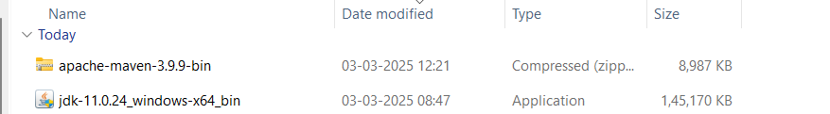

**Added paths**

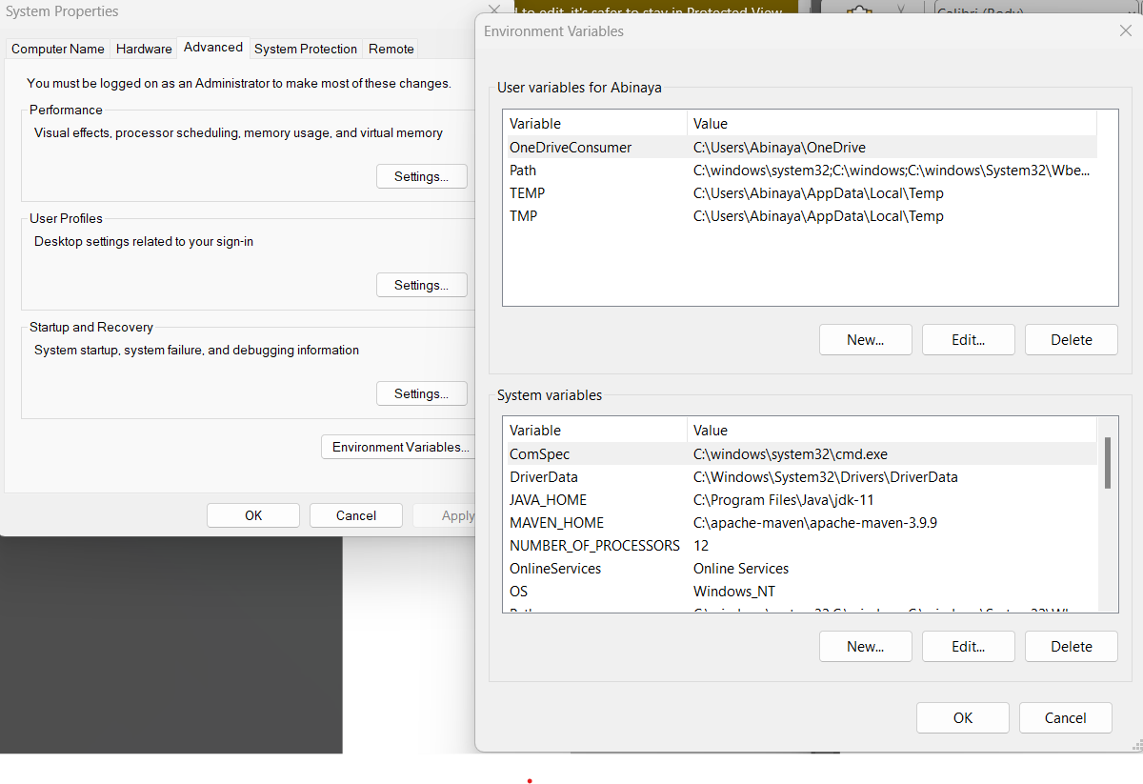

**Edited environment variables**

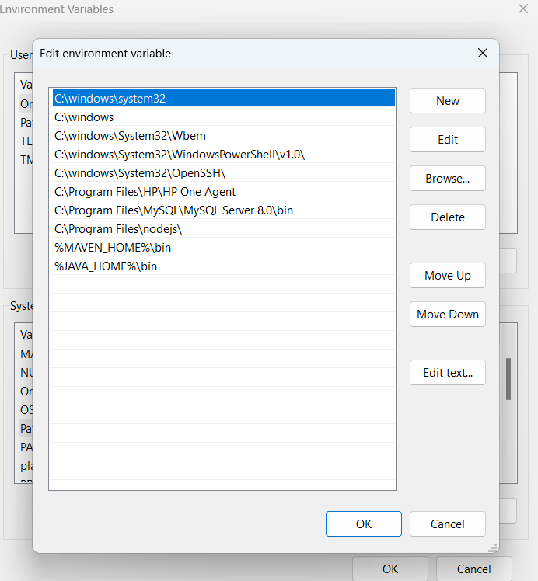

**Created a separate folder in C drive**

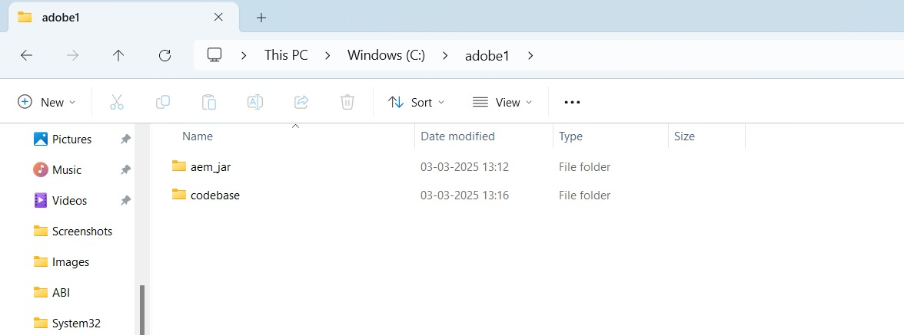

**OPENING AEM:**

**java -jar aem-author-p4502.jar**

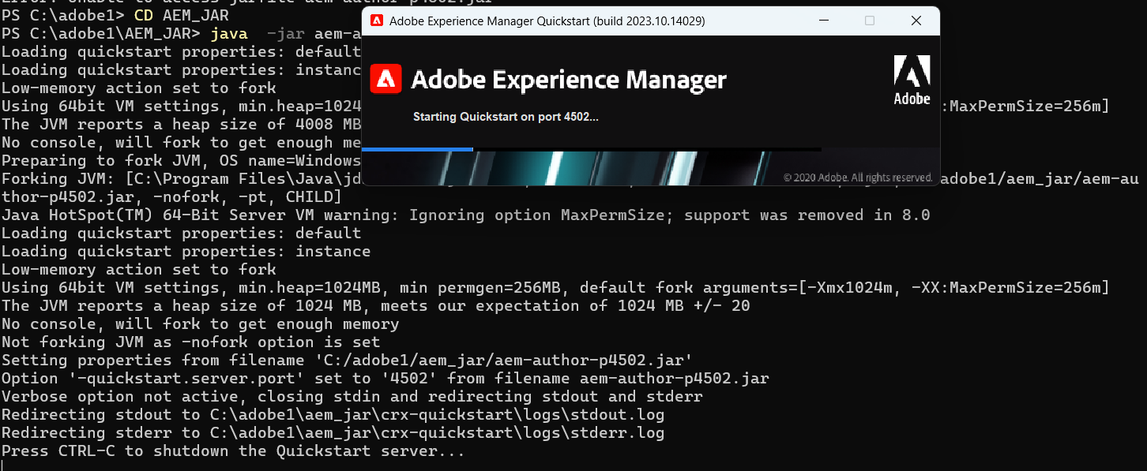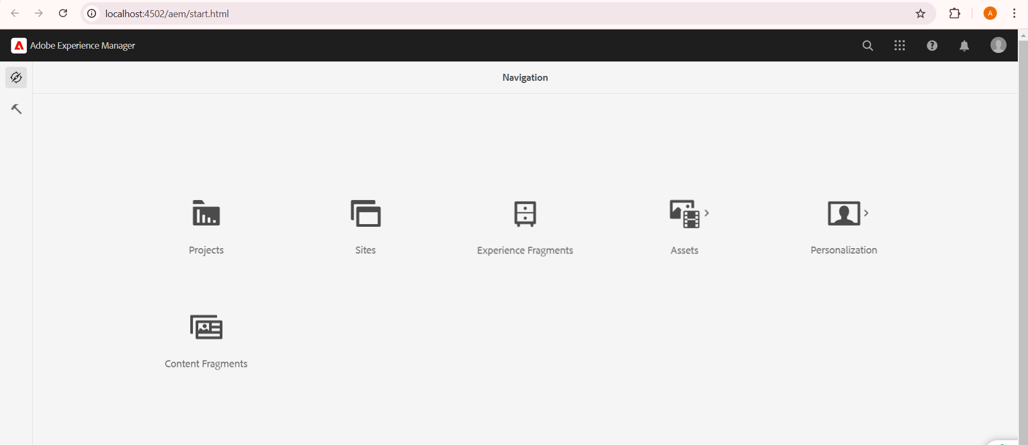

**Command run:**

mvn -B org.apache.maven.plugins:maven-archetype-plugin:3.2.1:generate -D archetypeGroupId=com.adobe.aem -D archetypeArtifactId=aem-project-archetype -D archetypeVersion=39 -D appTitle="myTraining" -D appId="myTraining" -D groupId="com.myTraining" -D aemVersion=6.5.5 -D includeExamples=n -D includeErrorHandler=y

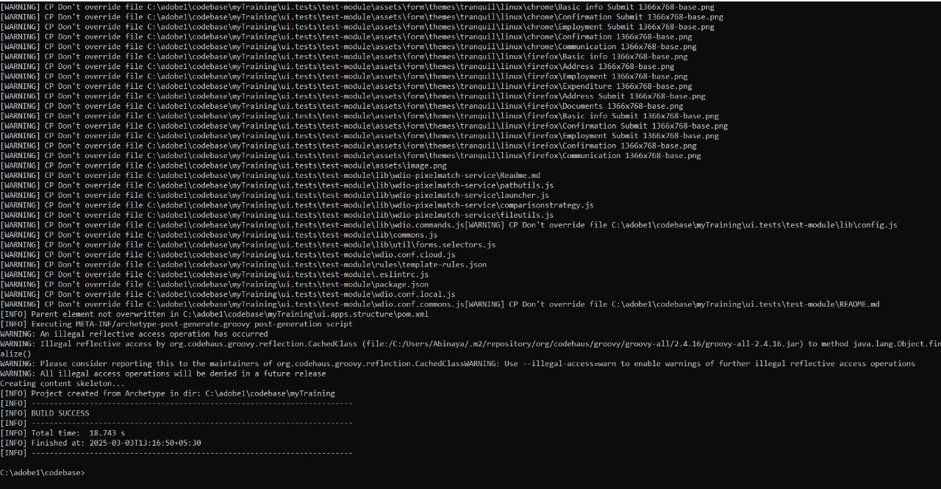

BUILD SUCCESS

**Project structure gets created**

